What is the main difficulty you’d like help changing?

When did this start? When do you notice it?
For example: at school, at home, at clubs, with friends, before tests, at night.

When it happens, what thoughts do you have?
If anxious, what do you worry might happen? If sad or low, what do you think about yourself or others?

How do you feel when this happens?
This could be feelings in your body or emotions (sick, worried, angry, butterflies in stomach)

What do you, or others do when this happens?
What helps, even just a little bit?

What would you like to be different?

Is there anything else we should know?

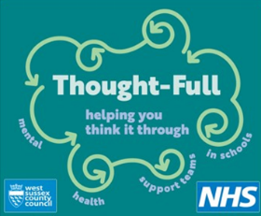
YOUR VOICE MATTERS

