SEND Parent Carer Involvement Policy Secondary (long version)

Parent programs and interventions work best when the strategies respect the needs of families. When school staff engage in caring and trusting relationships with parents that recognize parents as partners in the educational development of children, these relationships enhance parents’ desire to be involved and influence how they participate in their children’s educational development.” Henderson & Mapp, 2002

Why we value your involvement
Here at (name of school) we value parent involvement and strive for mutual support between our staff and the parent carers of all of our children, including those with Special Educational Needs and/or Disabilities (SEND)*. We aim to provide parents and carers with a wide range of opportunities to have a genuine say and play an active part in the planning of supportive provision for their child/young person.
Parent carers and families are the most important influence on children and young people’s lives. We recognise that by actively listening to parent carers, school staff can learn valuable information from their expertise and knowledge including the strengths and interests of these children and young people; strategies that work for them; how they prefer to communicate and what/who are important to them.
This involvement policy has been developed with parent carers to support their engagement in the education journey for their children with SEND. Perhaps most importantly, it is to ensure that our SEND children and young people feel emotionally and socially confident to share their strengths and to seek help if they feel they need it.

Recognising all parent carers have different preferences for getting involved with school
We recognise that parent carers are as individual as their children and that their needs, hopes and priorities may vary. This may mean that their level of involvement with school may also vary over the time their child attends this school. Equally, parent carers will have preferred ways of getting involved with, and communicating with, our school. We will be guided by our parent carers for their preferred means of communicating (e.g. emails, [schools to insert app for info here e.g. dojo/tapestry] letters, virtual meetings or in person meetings).

How you can be involved?
Parent carers of pupils with SEND in West Sussex have shared their experiences of involvement with schools and this policy is intended to reflect their feedback and nurture mutual positive relationships.
(School name) ‘s parent carers of pupils with SEND will be welcomed at all events open to all parent carers and in addition will be offered the opportunity to attend:
- Planning for Individual Learning Plans/Individual Education Plans (ILPs/IEPs)
- Completing checklists to help home and school gain a better understanding of individuals (e.g. sensory checklists, ADHD checklists)
- Annual reviews for Education and Health Care Plans (EHCPs)
- Meeting with our SENDCO and/or Learning Mentor to share any specific concerns you may have and/or to hear about specific emotional wellbeing or academic support planned and reviewed for your child
- Meeting with outside support services for schools (e.g. ASCT, LBAT, Educational Psychologists) to share experiences and feedback on any proposed support strategies
- Inclusion in the school SEND parent carer forum which allows parent carers of SEND children/young people to share their experiences, host outside speakers who can share information or support which is relevant for SEND children/young people and to feedback to school any ideas for building parent carer relationships.

Who can help and how?
There are also people who work for our school who can help you. We can offer help with form filling, accessing and downloading the school apps (e.g. SeeSaw, payment apps). Simply email the office at office@fictionalsecondary.sch.uk . Please explain in your email what you would like help with, and a member of staff will contact you within 48 hours.

Developing positive relationships with our parent carers of children and young people with SEND
A graduated approach to involving parent carers of SEND children and young people:
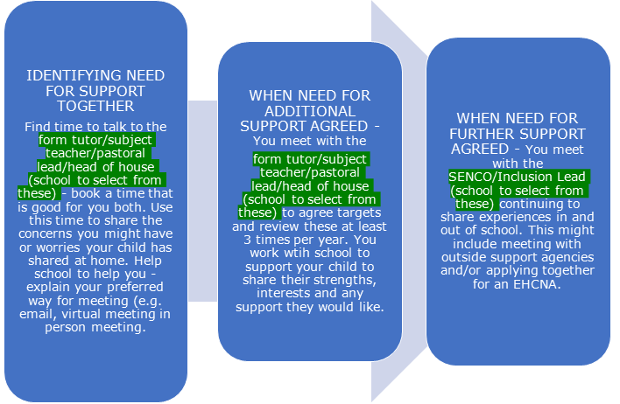

Helpful contacts
West Sussex Parent Carer Forum - WSPCF is an independent charity for the parent carers of children and young people aged 0-25 with special educational needs and/or disabilities (SEND). The charity supports parent carers by providing information, signposting, and training that equips them in their lifelong caring role and empowers them to participate in shaping services for their children and young people. - https://www.wspcf.org.uk/
Mini parent carer forums – to be added by individual school
Local support groups - to be added by individual school

Glossary of terms and abbreviations
*SEND – Special Education Needs and Disabilities. A child or young person with SEND is likely to need extra help that is additional to or different to their peers. The extra or different help is known as special educational provision. The SEND Code of Practice 2015 gives a legal definition of Special Educational Needs. You can learn more about the guidance in the SEND Code of Practice at https://www.gov.uk/government/publications/send-code-of-practice-0-to-25
ILP/IEP – Individual Learning Plan/Individual Education Plan. These plans identify targets for identified areas requiring specific additional support for individual children/young people and are monitored/reviewed as part of the ‘Assess, Plan, Do, Review’ process guiding support in West Sussex schools. https://schools.local-offer.org/send-toolkit/send/assess-plan-do-review/assess-plan-do-review-overview/
SENCO/SENDCO – Special Educational Needs Co-ordinator/Special Educational Needs and Disabilities Co-ordinator. This is a qualified teacher who has had extra training about SEND. They support teachers to arrange extra support for children and young people with SEND and are responsible for the day-to-day operation of the school’s SEN policy (available on school website).
ELSA – Emotional Literacy Support Assistant - https://www.elsa-support.co.uk/. ELSA’s are teaching assistants who have had special training from educational psychologists to support the emotional development of children and young people.
ASCT – Autism and Social Communication Team (advisory teachers and learning support assistants). The ASCT supports maintained and mainstream schools and academies promoting the educational, social and emotional development of autistic children and young people and children and young people with Social Communication Differences (SCD) through individualised advice, support and consultation.
LBAT – Learning and Behaviour Advisory Team (advisory teachers and advisory practitioners) also support maintained and mainstream schools and academies offering support for learning and/or behaviour difficulties affecting a children and young people’s progress in school through offering consultation and training in areas relating to learning and behaviour.
Ed Psych or EPS – Educational Psychologists or Educational Psychology Service. This team support assessments of CYP’s SEN and disability including EHCP assessments, advice to schools and pre-school planning and reviewing.
SENDIAS – Special Educational Needs and Disabilities Information Advice and Support Service. West Sussex SENDIAS provides impartial and confidential information, advice and support to children and young people who have SEND. They also offer this service to their parent carers.
EMTAS – Ethnic Minority Traveller Achievement Service supports full access to education and aims to raise the attainment pupils from minority ethnic backgrounds, particularly those with English as an Additional Language (EAL) and those from Gypsy, Roma & Traveller backgrounds (GRT). The team offers advice and guidance to schools and families, supports parental and community engagement and delivers a range of training.
EHCNA (Education, Health and Care Needs Assessment) - If a child or young person has been receiving SEN support for a while and is not making expected progress, the educational setting, parent carer or young person, if they are over 16, may consider requesting an assessment to see whether an Education, Health and Care Plan is needed.
EHCP (Education Health and Care Plan) – This is a legally-binding document which sets out the education, healthcare and social care needs of a child or young person for whom extra support is needed in school, beyond that which the school can provide through its Ordinarily Available Inclusive Practice (For WSCC OAIP see - https://schools.local-offer.org/send-toolkit/ordinarily-available-inclusive-practice/).
SENAT – Special Educational Needs Assessment Team is responsible for children with Special Educational Needs who have an Education Health and Care Plan (EHCP), are requesting one, or who are going through the process of an Education Health and Care Needs Assessment. They also process the monitoring and review functions of EHCPs (the Annual Review process).

